 |  | TERMO DE ACEITE TÉCNICO
Solicitante: VIVO- Projeto Escolas Rurais
NOC/Operador: Renan Borges Sousa |  |  | Cliente: VIVO
Empresa  EMC Brasil | VSAT-ID  VIVO-PER-23011360-CE |  | Link kbps  256/128 | Plataforma  VSAT
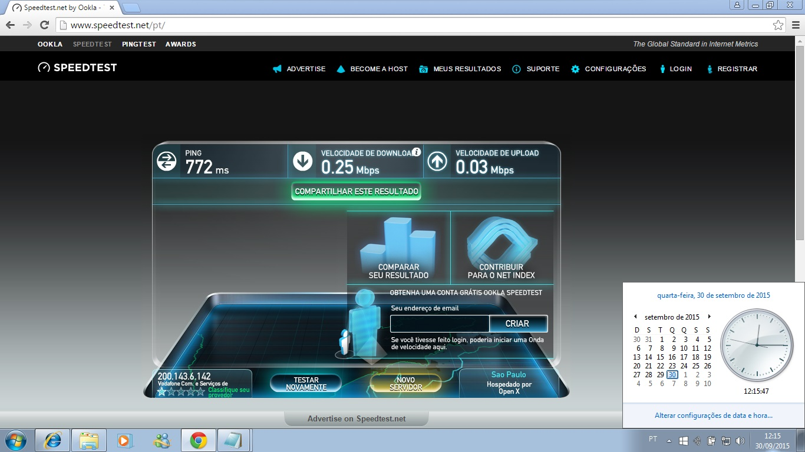
Satellite (DVB) RX Configuration
--------------------------------
Auto start : Enabled
Max MODCOD : 23 16APSK-9/10 (SNR threshold: 23.5 dB)
RX watchdog : 15 minute

Idx Pri SymbRate[Msps] Freq[GHz] Mode PopId Enable
* 0 0 9.320000 12.055825 DVB-S2 4 Yes
1 1 0.000000 0.000000 DVB-S2 0 No

Satellite (DVB) Receiver Status
--------------------------------
Rx State : On
DVB State : Forward link up
Network : 1326, GlobalIP@Telstar-14R
Frequency : 12.055841 GHz
Symbol Rate : 9.320070 Msps
S2 ModCod
- receiving : 16 8PSK-8/9
- current max : 23 16APSK-9/10
Pilot : On
Frame length : Short
DVB S2 Mode : ACM
Roll off : 0.25
SNR : 15.7 dB
Input Power : -28 dBm
#
Satellite (DVB) TX Configuration
--------------------------------
Auto start : Enabled
IDU Output Power : -15 dBm
IDU Max Output Power: 0.0 dBm
ODU Output Power : 33.7 dBm
EIRP : 47.0 dBW
Default CW Frequency: 0.000000 GHz
ATM mode : VC-Mux
Header Compression : None

Satellite (DVB) Transmitter Status
--------------------------------
State : On (TDMA)
IDU Output Power : -19.1 dBm
ODU Output Power : 33.7 dBm
EIRP : 47.0 dBW
Eb/No : 14.0 dB
Header Compression : Disabled
Timing correction : -136 us (260188 us)
Frequency correction: -340 Hz

IP DVB 10.53.1.12/32

#ping 8.8.8.8
# 64 bytes from 8.8.8.8: time=1020 ms
64 bytes from 8.8.8.8: time=790 ms
64 bytes from 8.8.8.8: time=950 ms
64 bytes from 8.8.8.8: time=870 ms
64 bytes from 8.8.8.8: time=940 ms

--- 8.8.8.8 ping statistics ---
5 packets transmitted, 5 received, 0.00 percent packet loss
rtt min/avg/max = 790/910/1020 ms

